Wireframe:
Page 1:
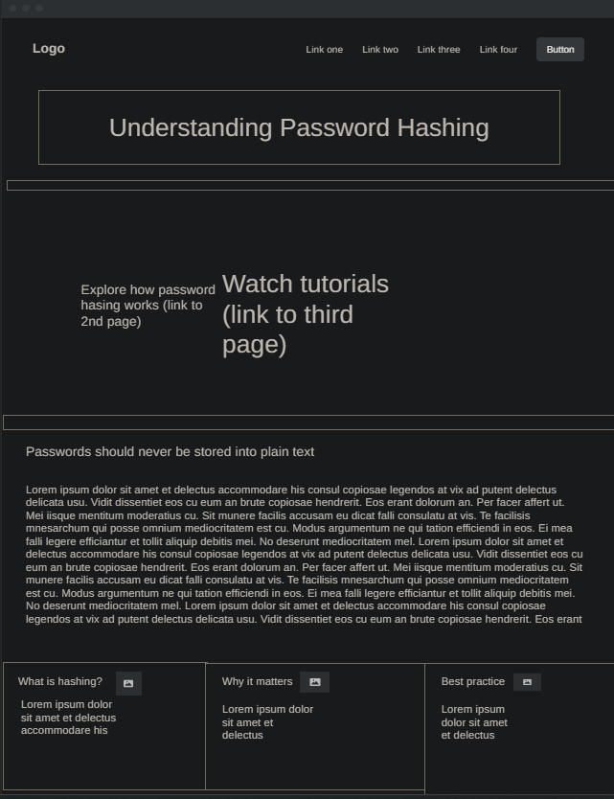
Page 2:
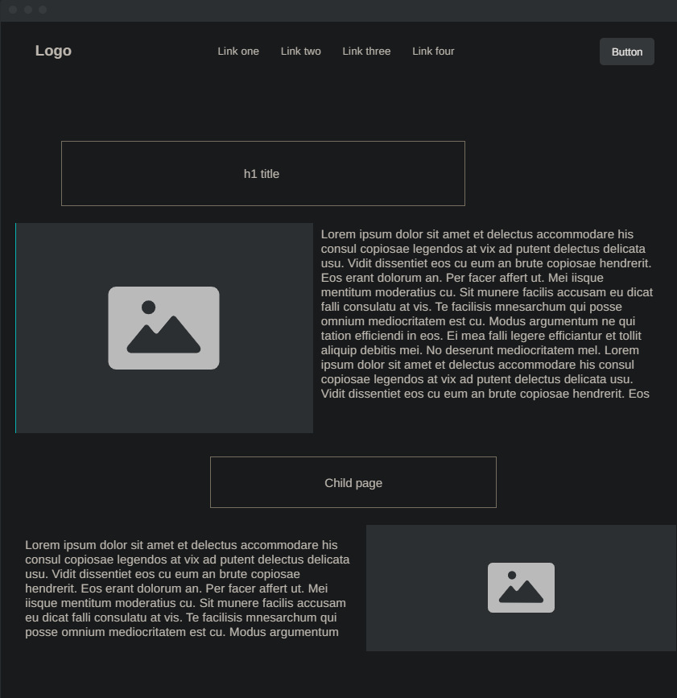

Page 3:
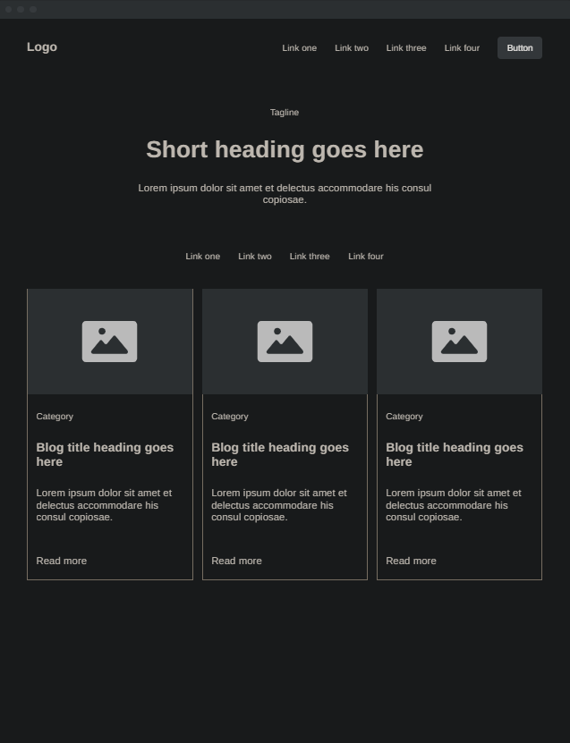
Purpose and Audience:
The website's purpose is to provide information about password hashing. These key elements are meant to inform daily users how password functionality works.

Logo:
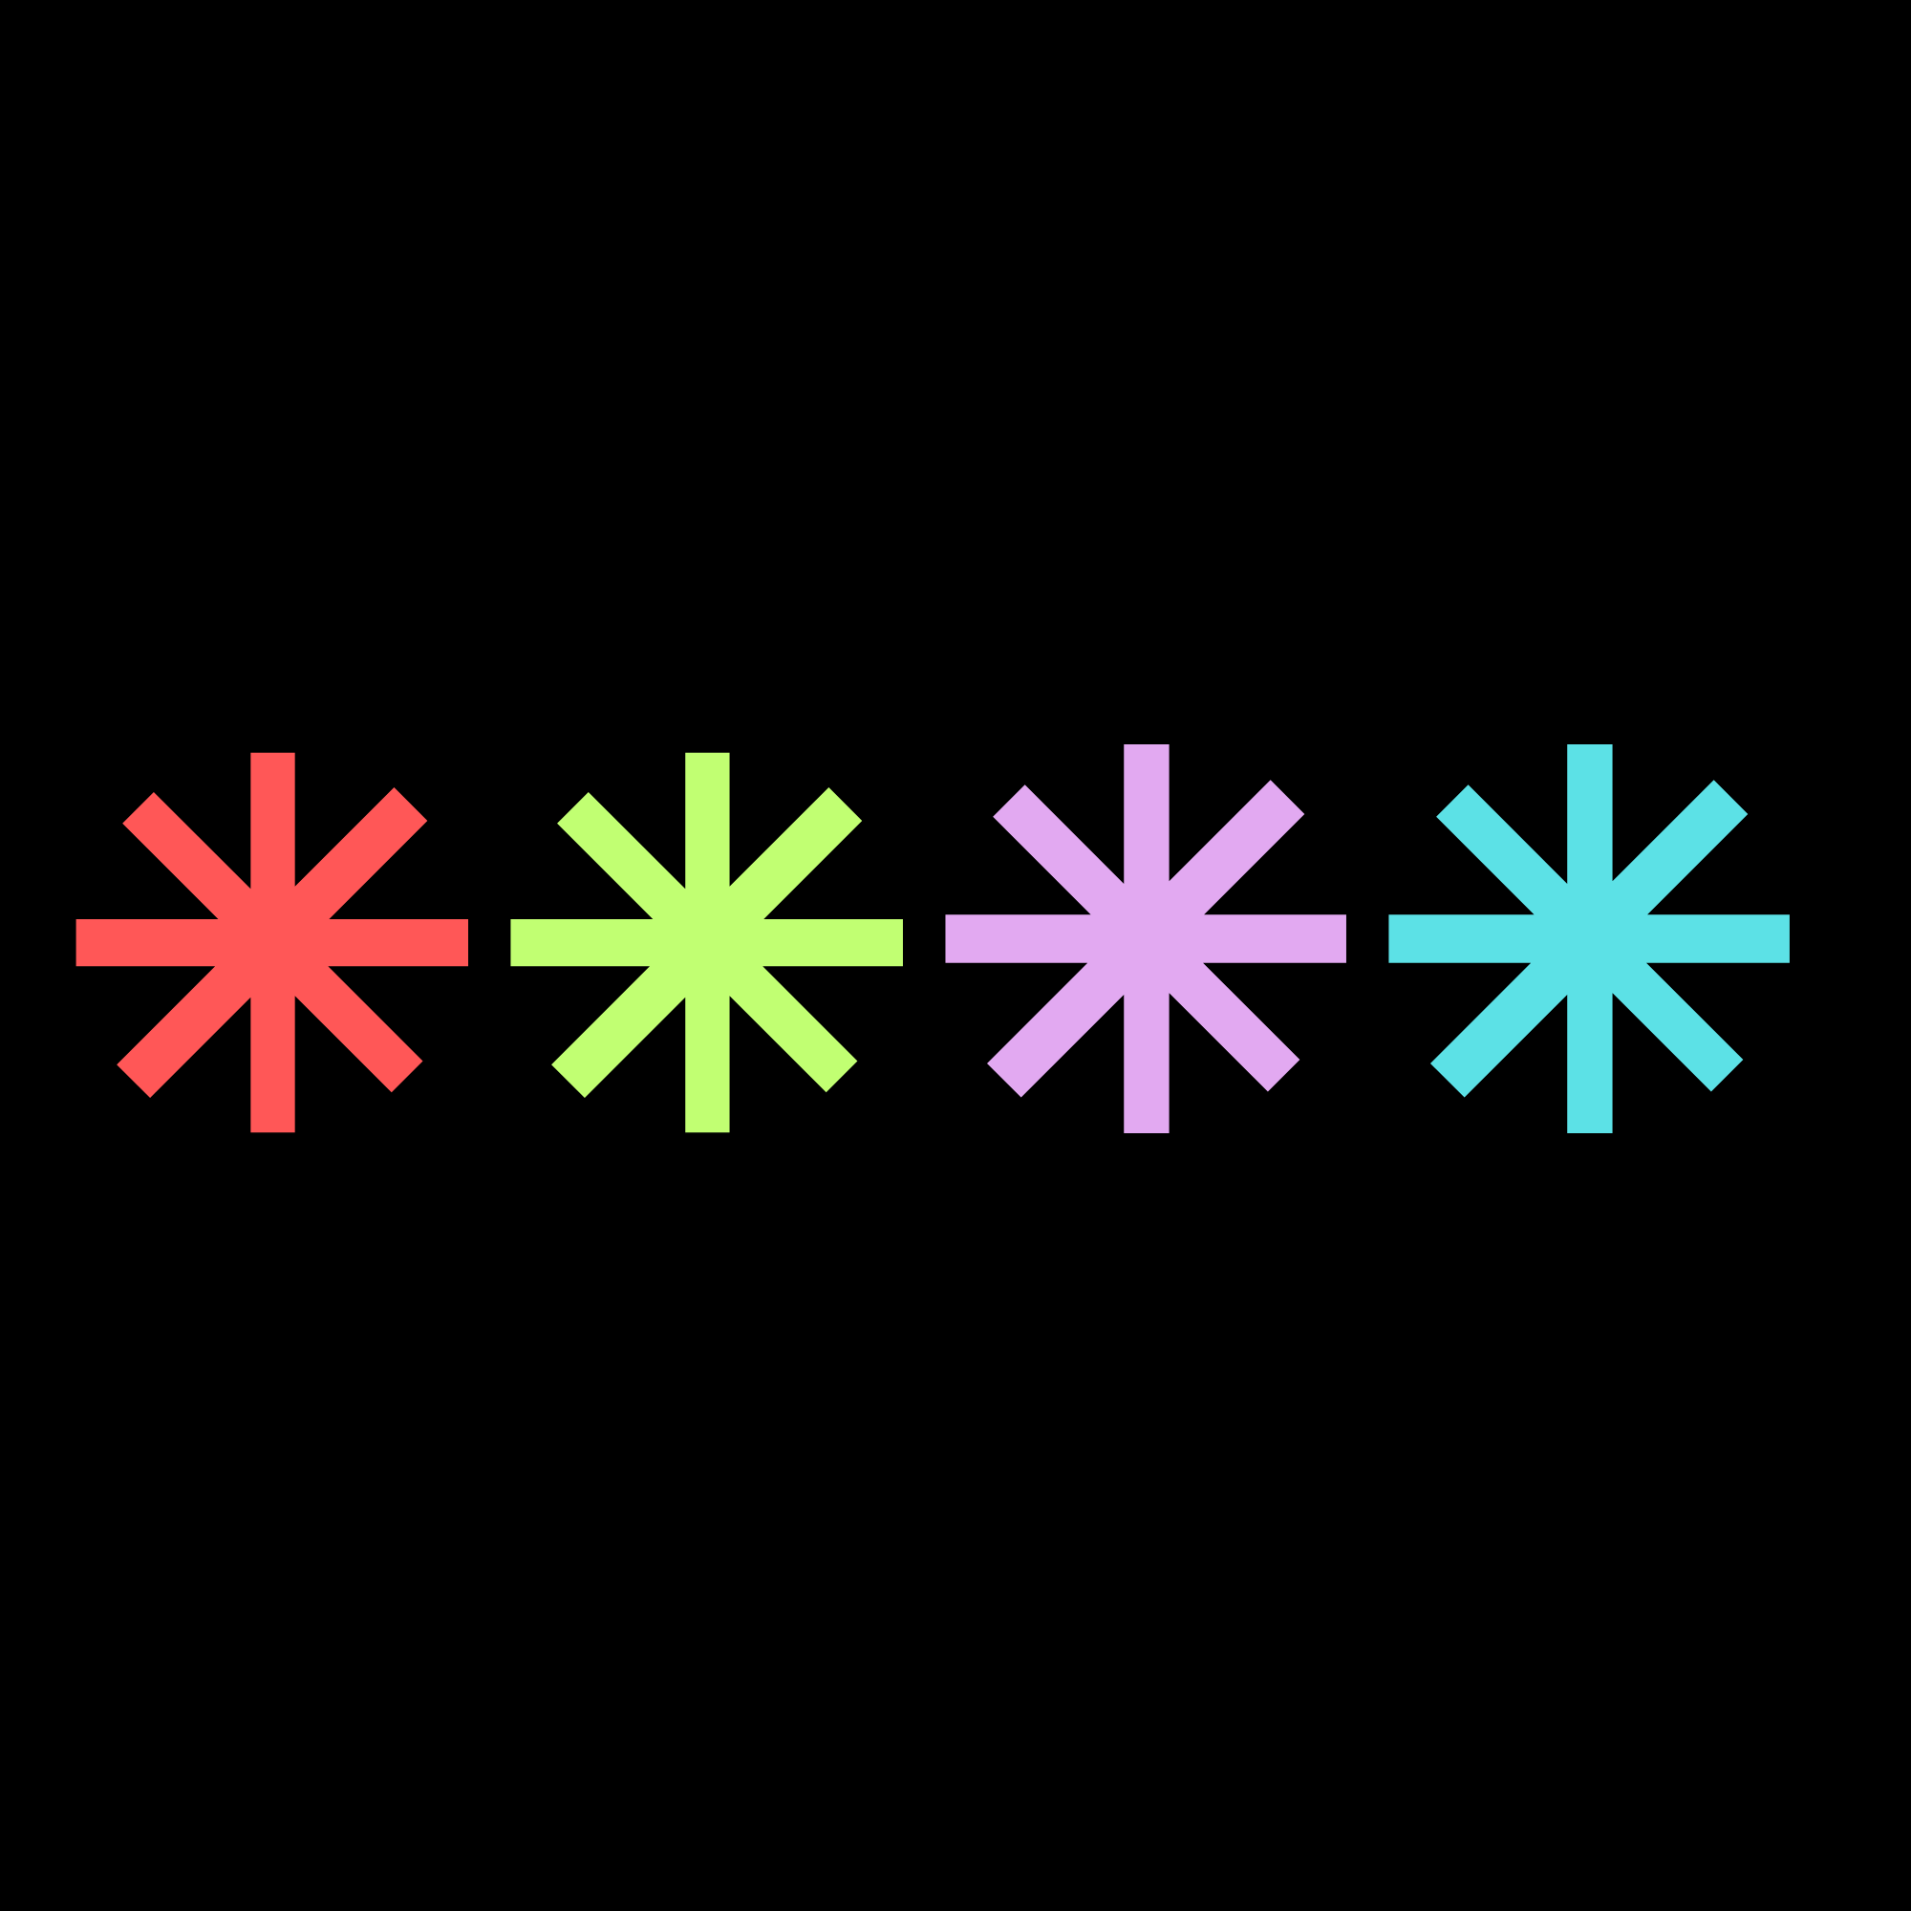

Colors and Fonts:
#0B0B0B
#56C2C7
#C49AD3
#C49AD3
#FF5757
#E5E5E5
- Roboto
- Orbiton
- Arial

